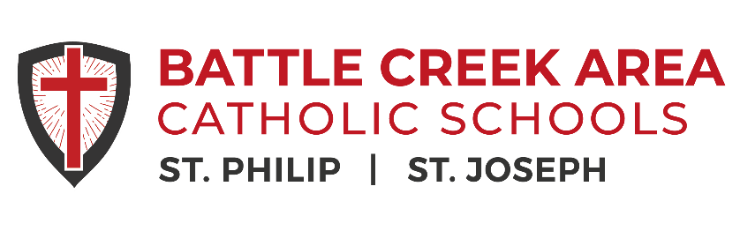

Spanish Teacher (Full-Time | 2026–2027 School Year)
Battle Creek Area Catholic Schools are seeking a faith-filled, collaborative Spanish Teacher for the
2026–2027 school year. This position may include instruction at both the middle school and high school levels. We serve students in grades 6–12 in Battle Creek, Michigan, and are committed to academic excellence, character development, and strong Catholic formation.
Responsibilities
• Plan and deliver engaging, standards-aligned Spanish language instruction
• Monitor progress, assess learning, and provide timely feedback
• Use data and technology to support and differentiate instruction
• Foster students’ language proficiency and appreciation for Spanish-speaking cultures
• Maintain a positive, structured classroom environment
• Communicate regularly with students, families, and colleagues
• Participate in school activities, meetings, and professional development
Qualifications
• Bachelor’s degree in Spanish, Education, or a related field
• Valid Michigan teaching certification with a Spanish (World Language) endorsement
• Strong communication, collaboration, and instructional skills
• Experience integrating technology to enhance learning
• Commitment to supporting diverse learners
• Willingness to incorporate Catholic values throughout the curriculum
• Prior classroom experience preferred
Join a dedicated team of educators committed to helping students grow academically, spiritually, and personally in a supportive Catholic school community. Please provide cover letter resume and references to:
Candidates should send cover letter, resume and references to:
Abbie Brennan, Director of Strategic Operations: abrennan@bcacs.org

